Meta title | Guide for Porting landline numbers to VOIP | United Telecoms (60)
Meta description | Number porting allows you to keep your existing geographic landline telephone number when changing from your existing service provider to a United Telecoms VoIP line. (166)  Keep your existing landline telephone number when changing to a United Telecoms VoIP line. Read more on United Telecoms! (120)
URL | https://unitedtelecoms.co.za/blog/landline-number-porting-guide/
Keywords | https://docs.google.com/spreadsheets/d/1LpQMZ4ppSBohwuwS1r2WK8HpwSw0CXdH-2D46Pz-5CI/edit?usp=sharing
Focus keyphrase | voip porting phone number number porting voip voip number porting Voip porting landline number to voip porting voip number to cell phone voip phone number porting porting telkom number to voip
Blog post is replacing this (updated and optimized): | https://unitedtelecoms.co.za/voip-and-hosted-pbx-resources/number-porting-all-you-need-to-know/

H1: Step-by-step guide: Porting landline numbers to VOIP in South Africa

Looking to port your number to VoIP and unlock a wide range of benefits for your business?

It’s no secret that VoIP offers lower costs, increased accessibility, clearer call quality, is more scalable and flexible to meet the demands of your business.

However, once you’ve made the decision to switch to VoIP, you’ll need to know how to port your landline number to VoIP and get answers to all of your important questions.

We’re here to make the process as smooth as possible. Find out how porting geographic landlines to VoIP works step-by-step, and learn about how to avoid delays during the number porting process.

H2: What is geographic landline number porting?

Geographic landline number porting allows you to keep your existing landline telephone number(s) when switching from an existing service provider to a VoIP line.

United Telecoms is a leading VoIP service provider in South Africa, and we allow you to port a Telkom number to VoIP or move your number over to VoIP from other providers like MWeb, Vodacom and Neotel.

When signing up for a VoIP telephone line or Hosted PBX Solution, you can keep your business’s landline numbers no matter where you are situated or moving to within South Africa.

We handle the entire number porting process for your new VoIP line, and we show you how to port a landline number to VoIP in a few easy steps.

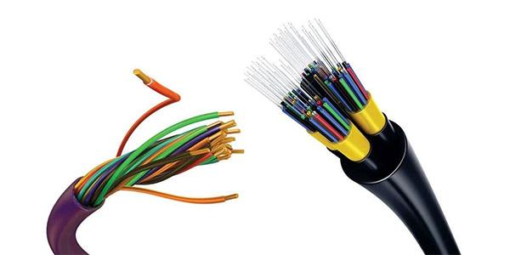

H3: What does VoIP number porting cost?
The cost of VoIP number porting in South Africa varies, however, the once-off fee for number porting usually ranges from R100 - R250.

United Telecoms charges R199.00 (excluding VAT) for a single telephone number to be ported to a VoIP service. For porting of more than 20 numbers, please contact us for pricing.

H3: Which telephone numbers can be ported to a VoIP service?

Geographic numbers and non-geographic numbers can be ported to a VoIP service.

Geographic numbers include, but are not limited to, numbers starting with 011, 043, 031, and 021. Non-geographic numbers starting with 0800, 0860, 0861, 0862, and 087, can also be ported to a VoIP service without difficulty.

Only geographical landline numbers can be ported to a VoIP service e.g. 011, 043, 031, 021, etc. Phone numbers that begin with 087, 080, and 086 unfortunately cannot be ported to a VoIP service.

H3: How long does the landline to VoIP number porting process take?
The landline to VOIP number porting process takes anywhere from 2 days, to two weeks in some instances. The number porting process can be delayed for a number of reasons, such as whether your existing account with your current service provider has an outstanding balance.

H3: Can you use your number while it’s being ported?
Your new service provider can provide you with a temporary telephone number for the duration of the porting process to ensure you can still make and receive calls as usual. All calls made to the number being ported can be forwarded to your temporary telephone number ensuring you do not miss a call.

On the day that number porting takes place, your VoIP service will be activated and you will no longer be required to use your interim phone solution and may be able to activate any softphones, integrations and use any physical phone systems you’ve linked to your new VoIP service/line.

H2: 5 Steps to port landline numbers to VoIP service providers
United Telecoms has assisted countless clients with porting their business numbers successfully to their new VoIP lines. We manage the entire number porting process to ensure it’s as seamless and as fast as possible

We break down the steps required to port landline numbers to VoIP in a few easy steps, below. We also encourage you to contact us, via email (info@unitedtelecoms.co.za) or to give us a call (086 001 8101) if you are in the market for a VoIP solution.

Follow the steps below and contact us for more help.

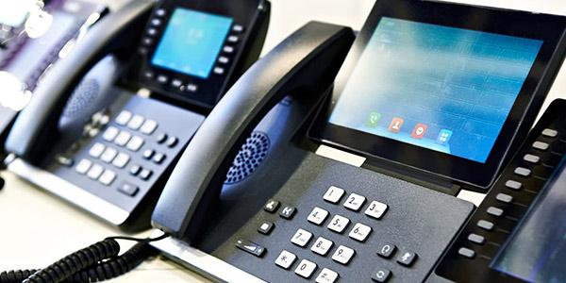

H3: 1. Ensure you have active account with your landline service provider
Before starting the number porting process, you will need to have an active account with your existing provider.

You won’t be able to port a landline number to VoIP if you have already cancelled the account associated with your landline number and/or you don’t have ownership of the number.

H3: 2. Ensure your payments are up to date with your current provider

Before porting your landline number over to a VOIP service provider, you need to ensure your account payments are up to date with your current landline provider.

As your account with your current landline provider will likely be cancelled once you have finished porting your number(s) over to VoIP, any outstanding balances will need to be settled.

Your current service provider (such as Telkom) will be able to assist you here before you begin the number porting process. A useful tip is to take note of your Account number and keep a recent copy of your latest invoice and/or statement on hand as these can speed up the number porting process.



H3: 3. Submit required documents to start the number porting process

To start porting your landline over to VOIP, you’ll need to submit a few documents to your new VoIP provider to start the process and ensure that you comply with South Africa’s RICA laws.

- A porting letter that is marked with your company’s letterhead.
This should state your request to port and authorise the person requesting the porting to do so. Please see porting letter template.
- A copy of the ID of the signatory making the request on behalf of your company.
- A recent phone bill from your current service provider.
- United Telecoms GNP (Geographic Number Porting) Authorisation Form.
Please contact us for more info and to obtain this form (info@unitedtelecoms.co.za).



H3: 4. Select a date to commence the number porting process after authorisation has been received

Once you’ve submitted all required documents to your new VoIP service provider, the porting process can take anywhere from a few days up to two weeks to complete. The ICASA authorities and Tier 1 Network will propose suitable dates to your service provider, allowing you to select when the number porting process will take place at a time convenient for you.

H3: 5. Start using your VoIP setup and cancel landline services

Once the number porting process has been finalised, and your VoIP service has been activated you can start to use your new VoIP connection to manage communications. Don’t forget to cancel your existing landline with your previous service provider - once your VoIP connection is up and running it is safe to do so.

H2: How to avoid landline number porting being rejected?
We’ve mentioned some of the ways landline number porting can be rejected, however, let’s cover all of the reasons why landline number porting might be delayed or rejected.



H3: Outstanding payments from your current service provider
As we have mentioned, it’s important to ensure all of your payments are up to date with your current service provider before switching over to VoIP.

Your current service provider won’t be able to start the number porting process and move forward with any landline cancellations as long as you have an outstanding balance due.

Contact your landline service provider to confirm the status of your account.

H3: Cancellation of services with current provider before porting
It’s important that you keep your landline service during the number porting process. If you cancel your landline rental before the porting process begins, you may lose ownership over your current landline number and not be able to keep your existing number when switching to a VoIP line.

If your number is linked to an ADSL line you will need to state this on the GNP authorisation form to ensure that when your number is ported you don’t lose access to your ADSL Internet service.

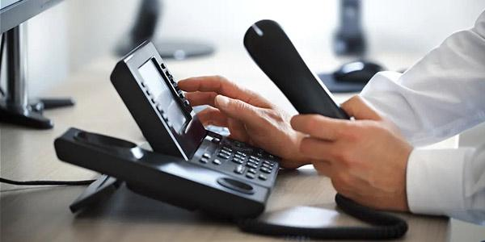

H3: If you don’t own the number you are trying to port
It may be obvious, but it’s worth stating that you can’t port a landline phone number that you don’t own.

Before asking for your number to be ported over to a VoIP provider, ensure that you have all of the required documents that show you own the number you are trying to port, and/or that you have the authority on behalf of your business to port a specific number.

H3: Other reasons VoIP number porting can be rejected:
- 1. The number(s) or number range is not valid on the existing service provider’s network or the number range is not exclusively used by the entity requesting the port.
- 2. The number(s) or number range is excluded from porting under regulations 3 new Number Portability Regulations implemented on 7 March 2022.
- 3. The account number provided is not the account number used by the existing service provider for the number(s) or number range for which the porting is requested.
- 5. The number(s) or number range is already subject to a porting process.
- 6. The number(s) or number range has already been ported in the last two months.



H2: Final thoughts on porting landline numbers to VOIP

We’ve taken you through how to port landline numbers to VoIP in a few easy steps, and you contact our team to guide you and manage the process from start to finish.

If you’d like to learn more about VoIP we would recommend exploring the benefits of VoIP for businesses, including a range of features to help you manage your company-wide communications more effectively.

Pairing your VoIP line with cloud PBX solutions can unlock more benefits and provide more accessibility and access to advanced features like live call monitoring, virtual attendant services, reporting and analytics, automated call distribution and more.

United Telecoms services provinces across South Africa, and can also assist clients based in Botswana, Zimbabwe, Swaziland, Namibia and Mozambique. We offer solutions ranging from micro, medium and large phone systems to suit the demands of a wide range of businesses. Contact us to find out more today!

